Generating BSDL files in Quartus II

Boundary Scan Description Language (BSDL) files for new devices (Stratix IV) now can be generated in Quartus II version 8.0 onwards. You can either generate a single BSDL file or all the BSDL files for the device family at one time.
This document is a guideline for you to generate the BSDL files in Quartus II.

Generating a single BSDL file in QII

There are two options for you to generate a single BSDL file.

Option 1:

Pre-configuration BSDL file
For Quartus II version 8.1 onwards, pre-configuration BSDL file can be generated before your design is ready by following steps below:

- Go to File → Create/Update → Create Board-Level Boundary-Scan File
- Select Pre-configuration and your targeted device as shown below:

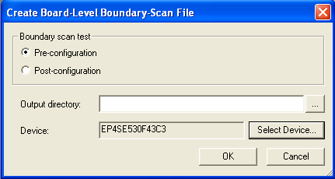

- Specify your output directory. If you leave blank for output directory as shown above, the generated pre-configuration BSDL file can be found in the directory below:

Your_working_directory\project_name

Post-configuration BSDL file
For Quartus II version 8.1 onwards, post-configuration BSDL file which is customized with your design can be generated after full compilation. To generate the post-configuration BSDL file, follow the steps below:

- Go to Assignments → Settings → EDA Tools Settings → Board-Level
- Select Post-configuration BSDL file as shown below:

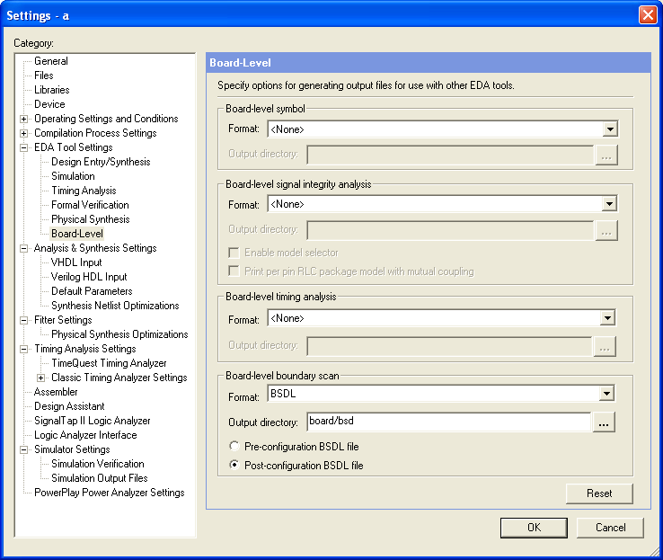

- The BSDL file will be generated when you click for full compilation. The BSDL file can be found in the directory below:

Your_working_directory\project_name\board\bsd

Option 2:

If you wish to have a BSDL file before the design is ready, below are the steps:

- First, create your own working directory which you would like to put the generated BSDL file in.
- Go to Command Prompt and run the command below to get the BSDL file that you would like to.
quartus_eda --bsdl <device_name>

* <device_name> must include the speed grade of the device.

- The BSDL file will be generated in the working directory that you created.
- Below is an example on how to generate the BSDL file in Command Prompt. The <device_name> here is EP4SE70F1517C3. The BSDL file will be generated in the working directory. In this example, the working directory named ‘quartusbsdl’.

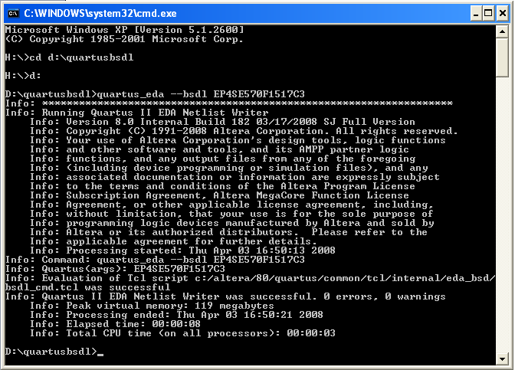

Generating all the BSDL files for the device family in QII

- Create your own working directory.
- Download the Tcl script which is used to generate the BSDL files in Quartus II from website. The Tcl script is available in the link below:

http://www.altera.com/support/devices/bsdl/bsdl.html

- Save the file in your working directory.
- Modify Tcl script –
  - Below is the tcl script that you downloaded from the web, replace the “Family name’ to the family that you would like to generate. For example, if you would like to get all the Stratix IV BSDL files, replace the ‘Family Name’ below to ‘Stratix IV’.

load_package device
set family “Family Name”
#get available part for the family
set part_list [get_part_list -family $family]

foreach part $part_list {

if {[catch {exec quartus_eda --bsdl $part} result]} {
puts "\nResult: $result\n"
puts "ERROR: Command line compilation failed. See report files.\n"
}
}

- Save your modified tcl file and go to Command Prompt to run the tcl script by using this command as shown below

quartus_eda –t <tcl_file_name>

- All the BSDL files for the particular family will be generated in your working directory.
- Below is an example on how to generate all the BSDL files in Command Prompt. ‘test2.tcl’ is the <tcl_file_name> that used in this example. All the available BSDL files will be generated in working directory named ‘quartusbsdl’ in this example.

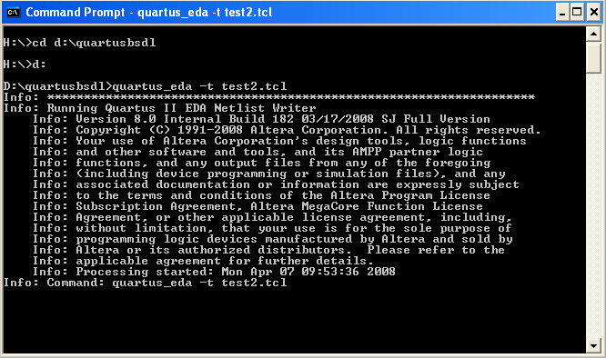

Revision History

Date | Description of Change
5/12/2008 | Initial Release
11/21/2008 | Update pre-configuration BSDL file and post-configuration BSDL file generation guideline in the option 1 for Quartus II version 8.1 onwards.

