**Instruction**

1. Please refer to the Excel sheet in the NUC or BCPU Zip file to identify the correct packaging and product labels. Use the Label Identifier (either a number or a letter) to quickly locate the correct AI File.
2. Please refer to the AI file in the NUC or BCPU Zip file to find the correct labels
3. Please print the labels with the minimum size requirement described below:

**Note:** If it is N/A under the packaging identifier, please still apply the associated product label

**Product label minimum size requirement:** (please note that this is not an actual symbol)

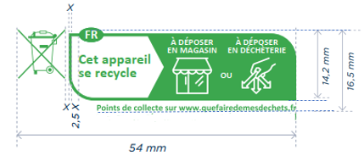

**Packaging label minimum size requirement:** (please note that this is not an actual symbol)

